**SALES TRENDS ANALYSIS**

**Creating Table**

DROP TABLE IF EXISTS sales_data;

CREATE TABLE IF NOT EXISTS sales_data

(

order_date DATE;

customer_name VARCHAR,

state VARCHAR,

category VARCHAR,

sub_category VARCHAR,

product_name VARCHAR,

sales DECIMAL,

quantity INT,

profit DECIMAL

);

**View all sales data:**

SELECT *

FROM sales_data

**1.Total sales, quantity, and profit:**

SELECT

SUM(Sales) AS Total_Sales,

SUM(Quantity) AS Total_Quantity,

SUM(Profit) AS Total_Profit

FROM sales_data;

**Output:**

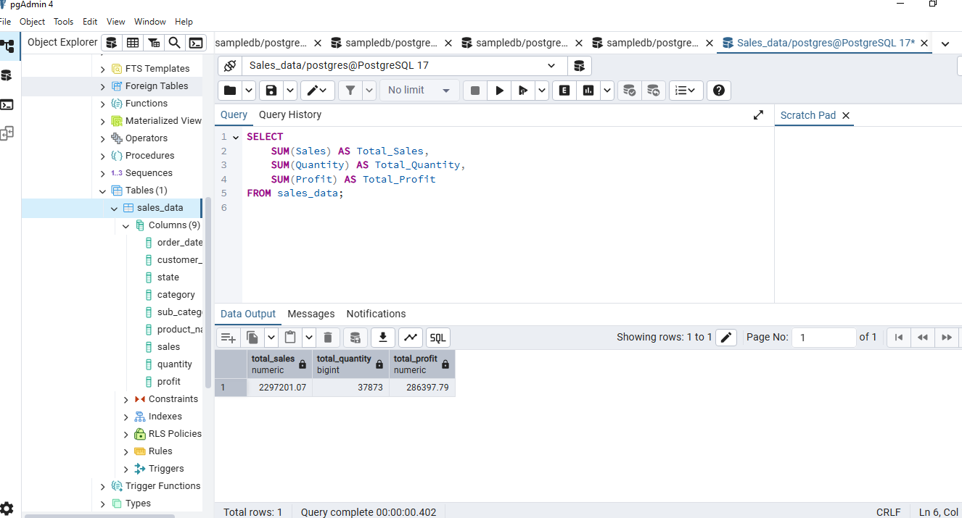

**2.Sales by category**

SELECT

Category,

SUM(Sales) AS Total_Sales

FROM sales_data

GROUP BY Category

ORDER BY Total_Sales DESC;

**Output:**

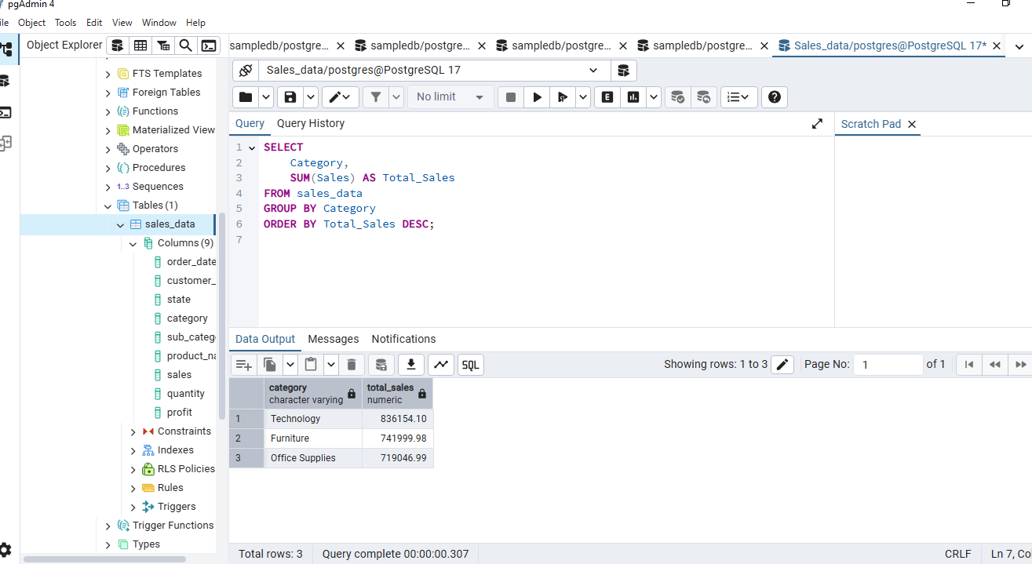

**3. Top 5 states by sales.**

SELECT

State,

SUM(Sales) AS Total_Sales

FROM sales_data

GROUP BY State

ORDER BY Total_Sales DESC

LIMIT 5;

**Output:**

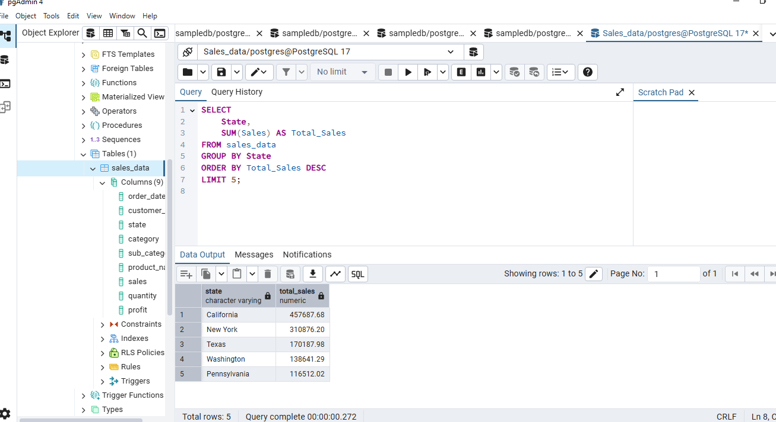

**4.Most profitable products**

SELECT

Product_Name,

SUM(Profit) AS Total_Profit

FROM sales_data

GROUP BY Product_Name

ORDER BY Total_Profit DESC

LIMIT 10;

**Output:**

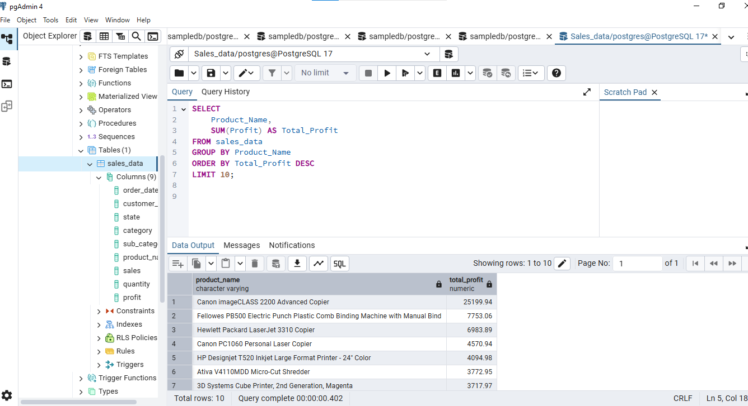

**5. Monthly sales trend.**

SELECT

extract(month from order_date) as month,,

SUM(Sales) AS Total_Sales

FROM sales_data

GROUP BY Month

ORDER BY Month;

**Output:**

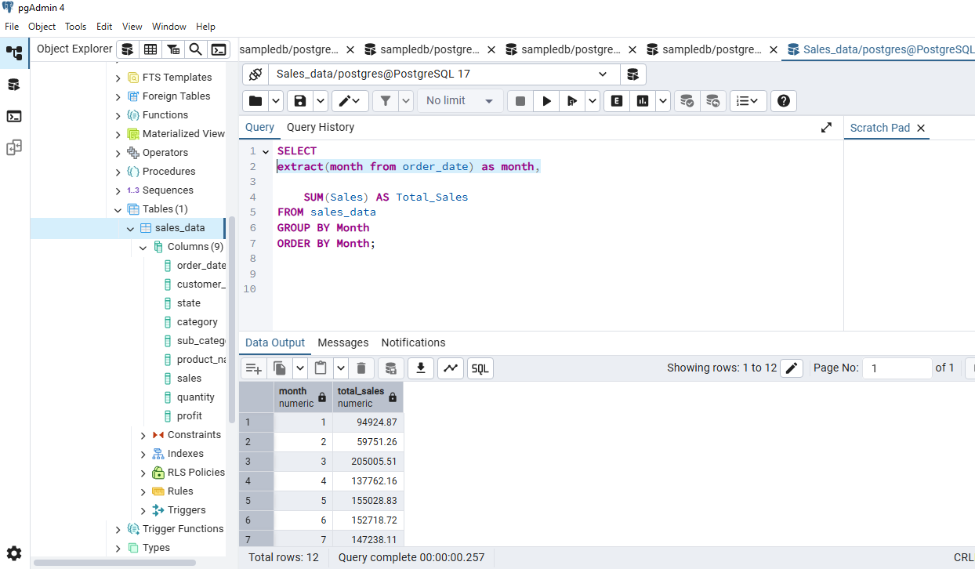

**6. Customers with highest total purchases**

SELECT

Customer_Name,

SUM(Sales) AS Total_Sales

FROM sales_data

GROUP BY Customer_Name

ORDER BY Total_Sales DESC

LIMIT 10;

**Output:**

